EXPERIMENT 3 CAR BOOKING RESERVATION

Step1: Create the application form

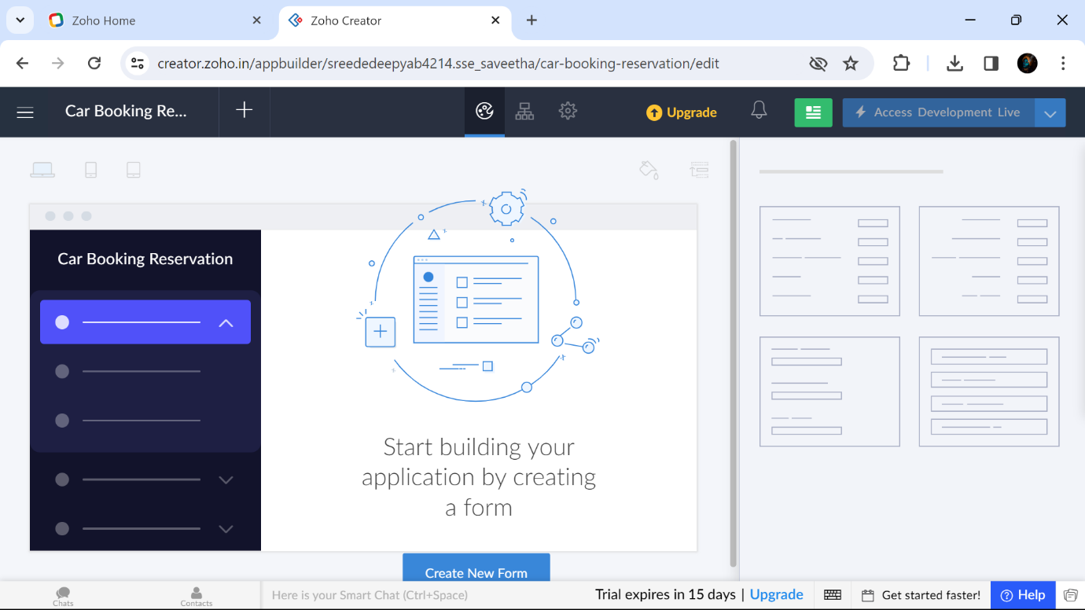

Step:2 Create a form called Personal Details

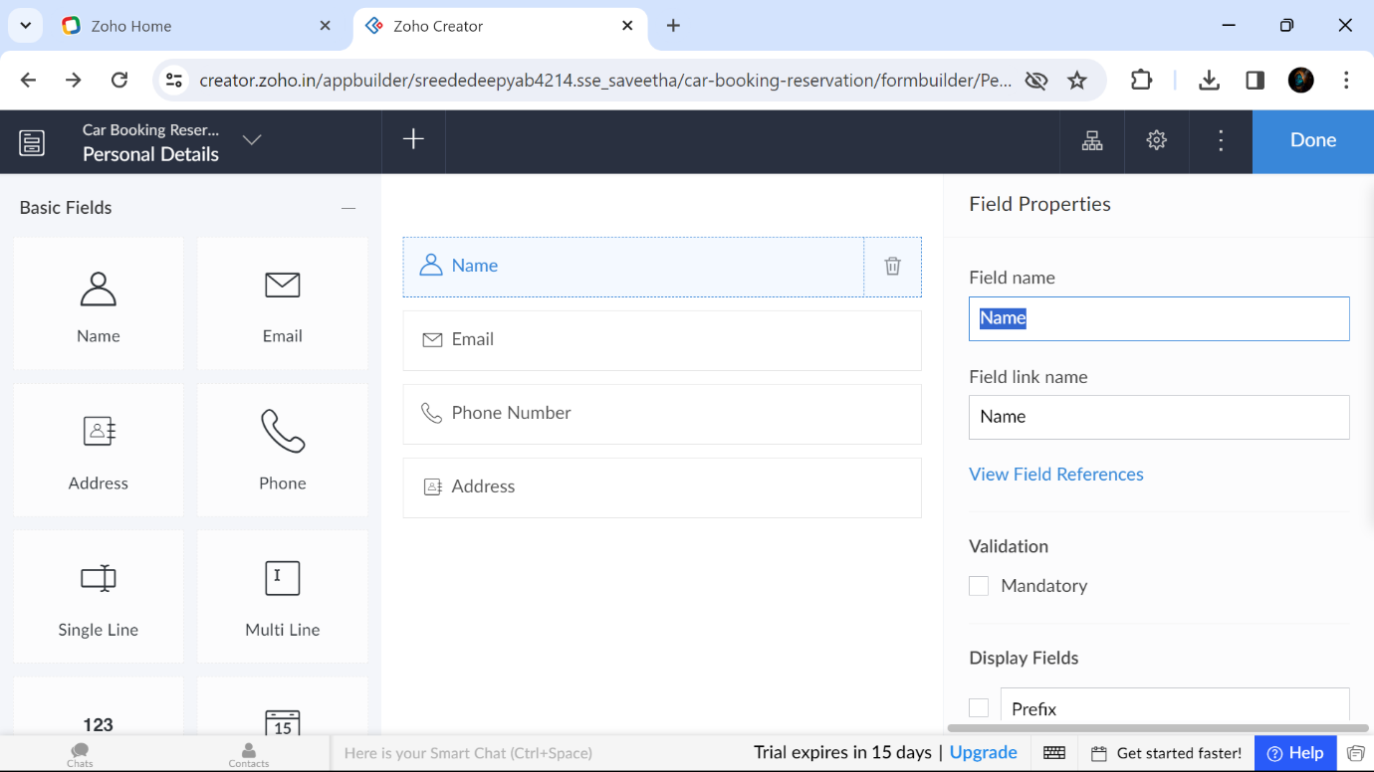

Step3: Create a form called Car To Buy and Create a form called Car for rent

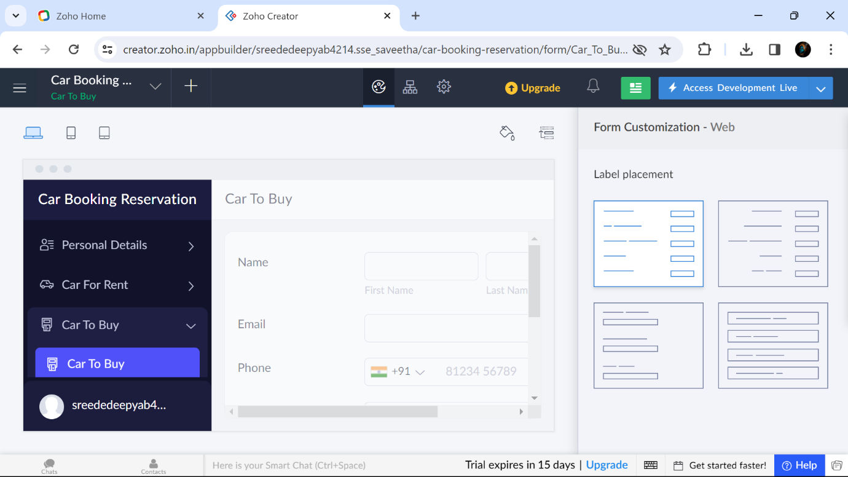

Step 4: The form called ‘Personal Details’ was filled by these details

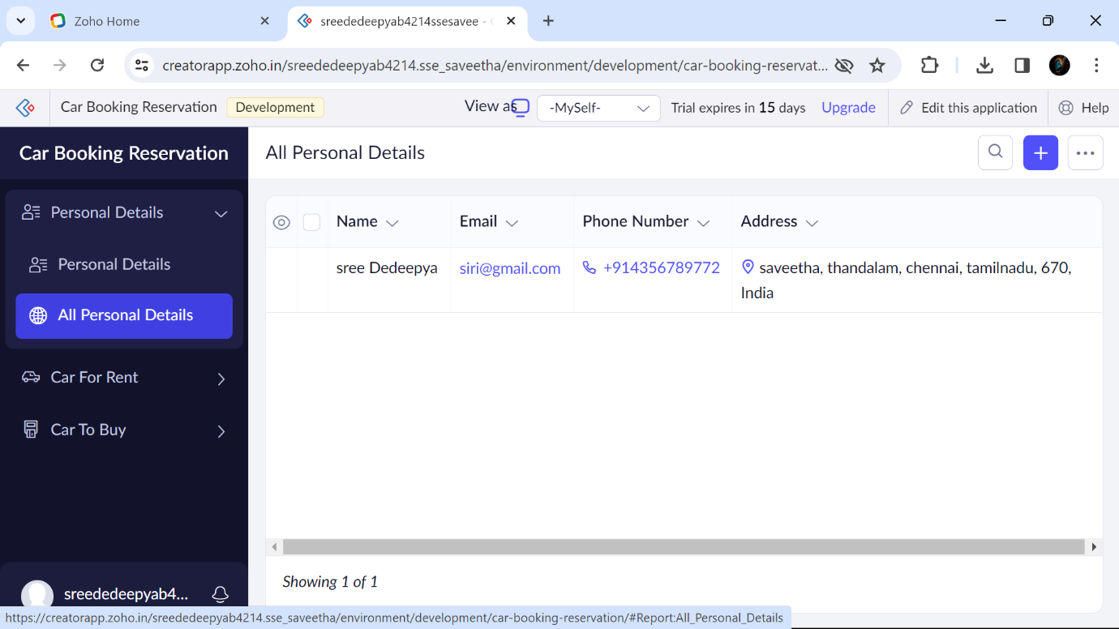

Step 5: The form called ‘Car for Rent’ was filled by these details

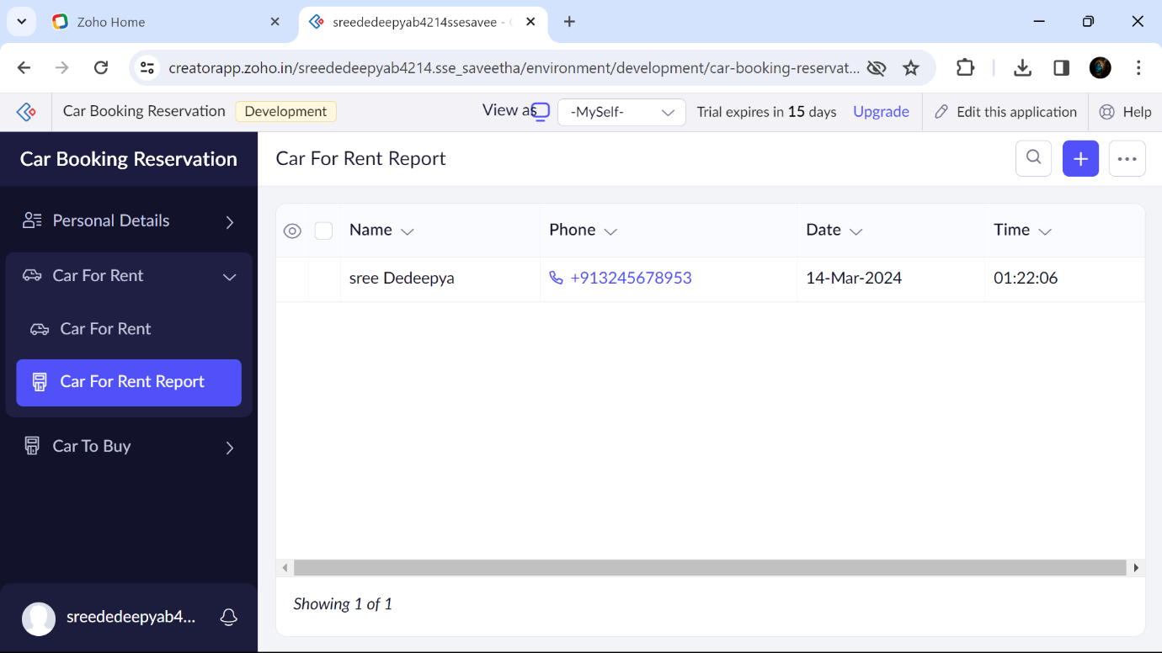

Step 6: The form called ‘Car to buy’ was filled by these details

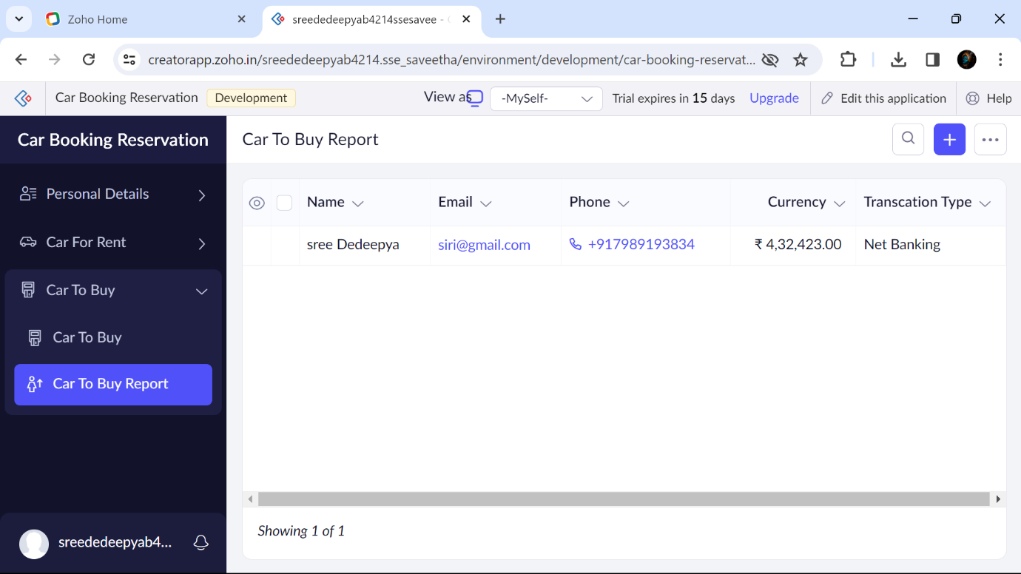

B.Sree Dedeepya 192224214